Hot Water Recirculation System
By Chris Hayes
October 2020
Email: chris@shawcomms.com.au
Website – www.shawcomms.com.au
Design
Water design:
Diagram of system components and water flow
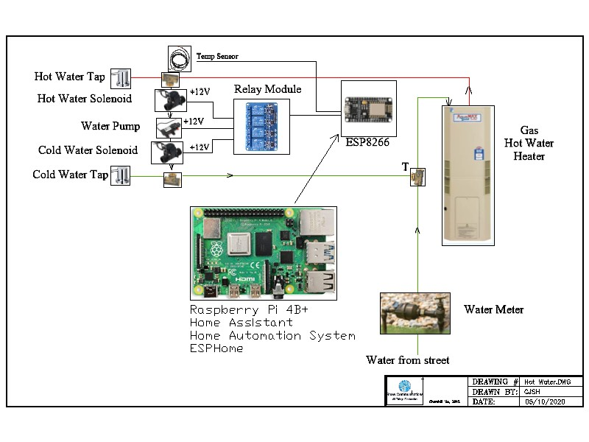
Pump the Hot water line back into the Cold water line at the kitchen sink. The hot water will flow back towards the Cold water input of the water heater. Once the Hot water has arrived at the Solenoids the temp sensor detects that hot water arrived and turns off the solenoids and pump.
No water is lost in this process as it is a close loop water recirculation system.
Tape the temperature sensor to the hot water Tee piece (must be metal not plastic).
Electrical Design:
Processor:
Use of the ESP8266 was to remote the controls/interfacing to the Raspberry Pi which is a Home Automation – Home Assistant and ESPHome system.
Use low energy devices – ie ESP8266. Raspberry Pi.
Display:
This not actually necessary but I decided to add for uniqueness. It does draw a lot of current and if not really needed then can be removed. I may add a LCD Display power line relay control so when the motion sensor triggers the relay and thus turn on the display, this needs to be tested.
Power:
Use low energy devices – ie ESP8266. Raspberry Pi.
Preferred type Solar:
Battery: 12 volt dc 14 ah battery
Solar panel: 16 volt solar panel
Charger: via Lead acid charger
DC-DC converter – 12Vdc to 5Vdc
Temp Sensor power from ESP8266 3V3 output
Caution:
There are issues with voltage levels.
+12vdc to run Relays
+5vdc to run
- ESP8266
- Motion Senor (does not run on 3v3, use Note 1 below)
- LCD Display (does not run on 3v3)
Note 1: I used a voltage divider to adjust the 0-5 volt coming from the Motion sensor. I used a 820/1k2 resistor voltage divider to adjust the voltage to a 0-3v3 signal which will be compatible with the
ESP8266 GPIO voltage divider to overcome the limits.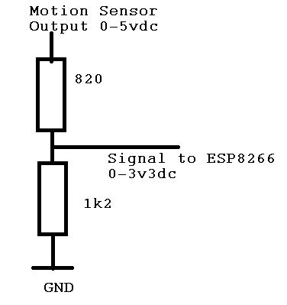

Materials:
Raspberry Pi - Software
- Home Assistant
- ESPHome
ESP8266
Motion Sensor
Relay Board - 4 relay board module – Opto isolated
Temp Sensor – Dallas Temp Sensor
Display - LCD screen 16x2 - I2C device
Battery - 12 Volt Battery system
Charging System - Solar Charger including a 12 Volt Solar Panel
Water Valve – Solenoids X2 – 12 volts
Water Pump - 12 volts
BOM: Components required
Raspberry Pi 4
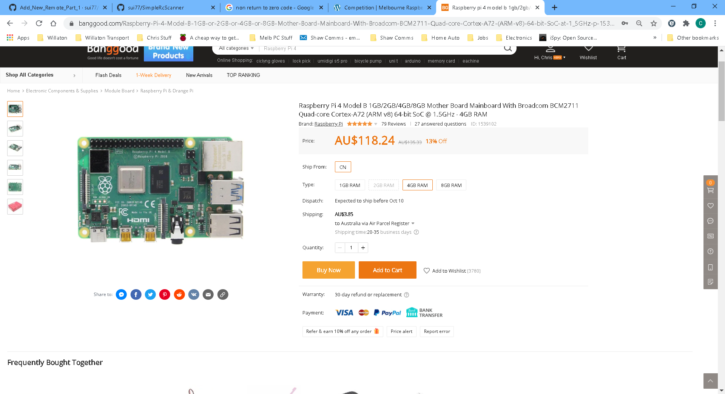
Link:
https://www.banggood.com/Raspberry-Pi-4-Model-B-1GB-or-2GB-or-4GB-or-8GB-Mother-Board-Mainboard-With-Broadcom-BCM2711-Quad-core-Cortex-A72-(ARM-v8)-64-bit-SoC-at-1_5GHz-p-1539102.html?rmmds=search&ID=6285955&cur_warehouse=CN

ESP8266 – nodemcu (not specifically required just a ESP8266)
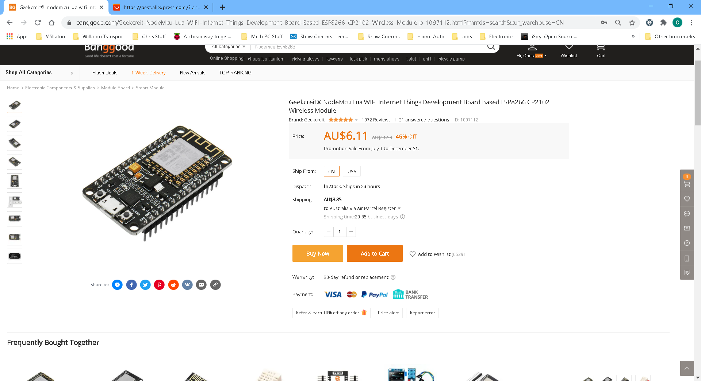
Link:
https://www.banggood.com/Geekcreit-NodeMcu-Lua-WIFI-Internet-Things-Development-Board-Based-ESP8266-CP2102-Wireless-Module-p-1097112.html?rmmds=search&cur_warehouse=CN
Motion Sensor
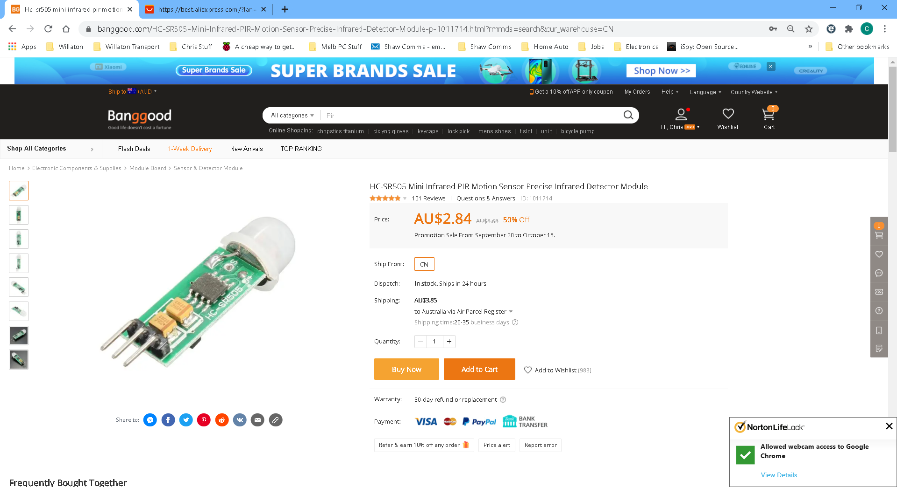
Link:
https://www.banggood.com/HC-SR505-Mini-Infrared-PIR-Motion-Sensor-Precise-Infrared-Detector-Module-p-1011714.html?rmmds=search&cur_warehouse=CN

LCD Display
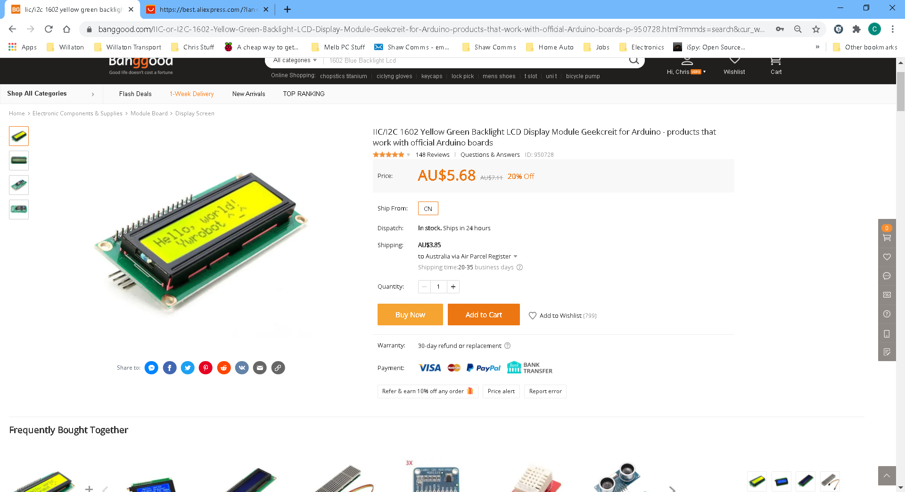
Link :
https://www.banggood.com/IIC-or-I2C-1602-Yellow-Green-Backlight-LCD-Display-Module-Geekcreit-for-Arduino-products-that-work-with-official-Arduino-boards-p-950728.html?rmmds=search&cur_warehouse=CN
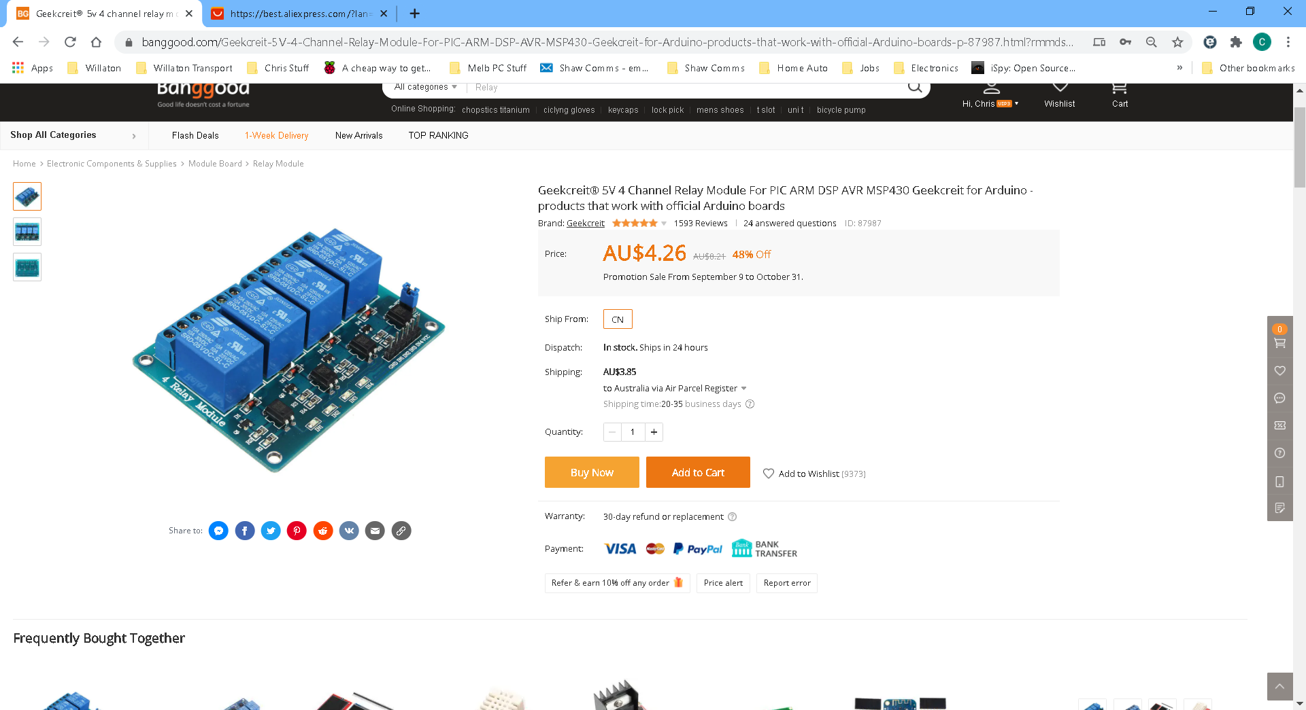
Link:
https://www.banggood.com/Geekcreit-5V-4-Channel-Relay-Module-For-PIC-ARM-DSP-AVR-MSP430-Geekcreit-for-Arduino-products-that-work-with-official-Arduino-boards-p-87987.html?rmmds=search&cur_warehouse=CN
Temp Sensor
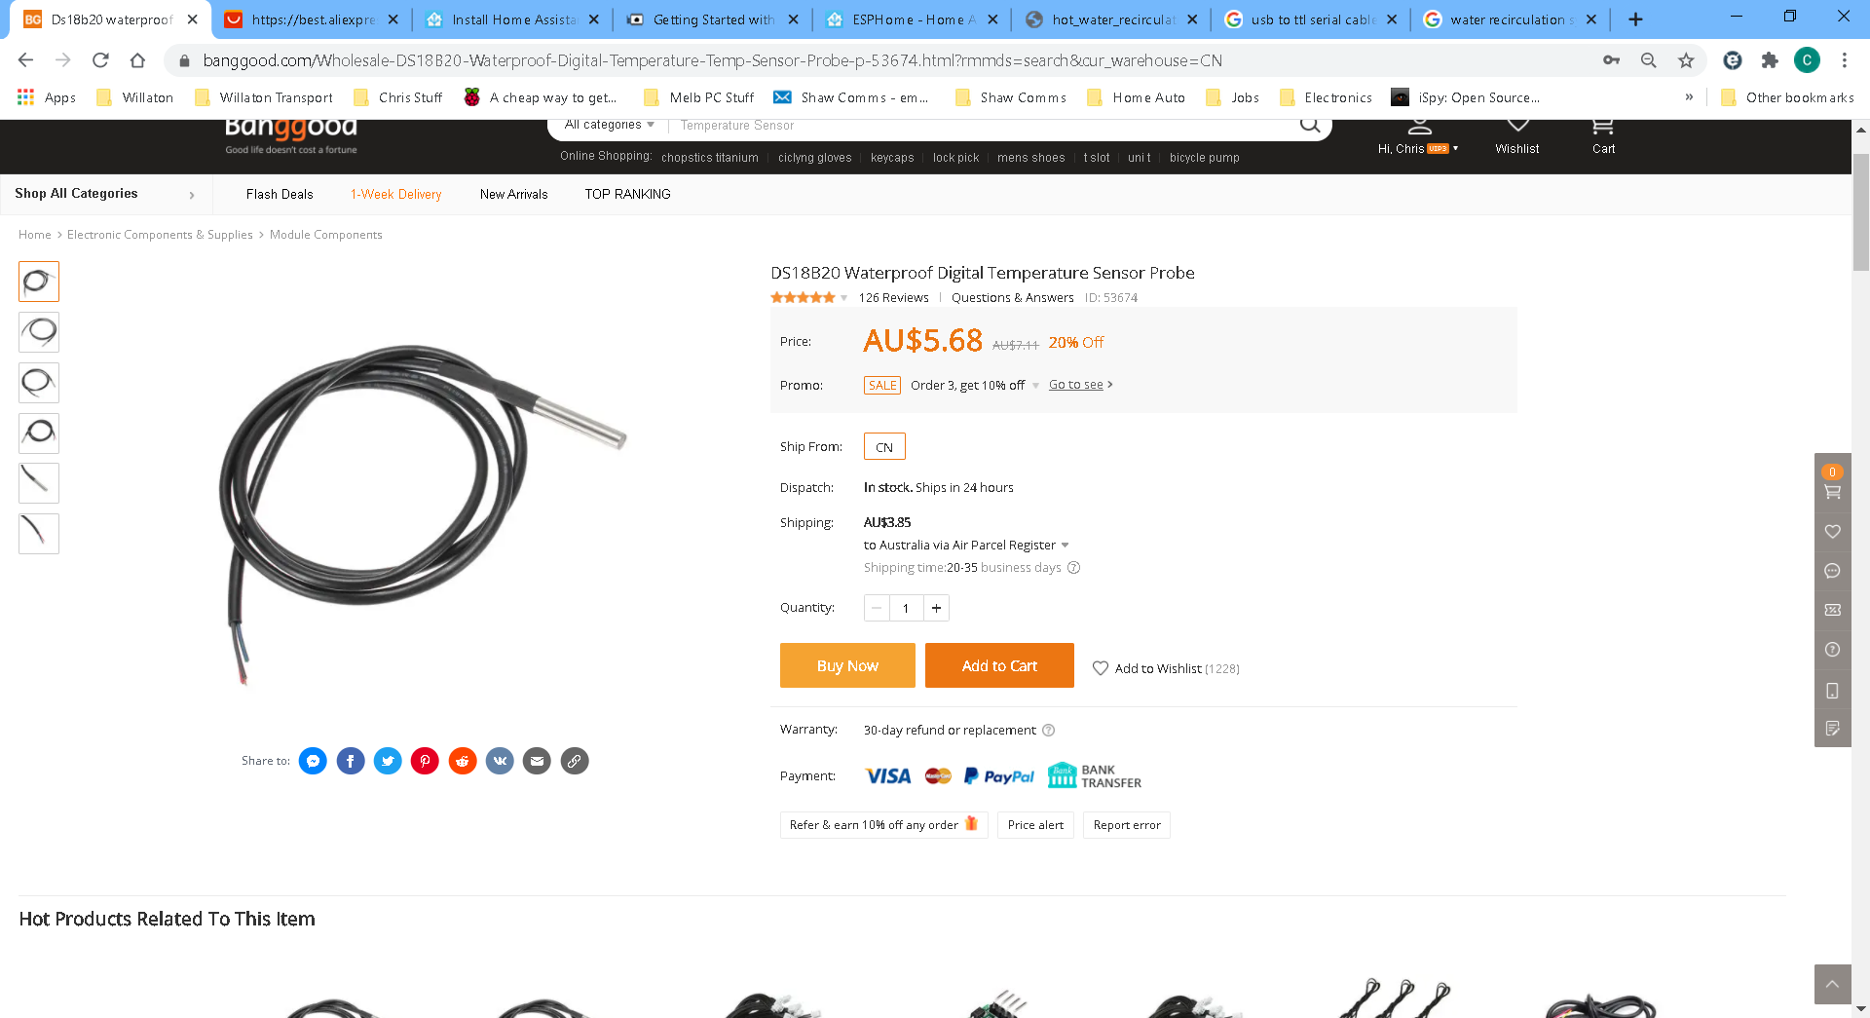
Link: https://www.banggood.com/Wholesale-DS18B20-Waterproof-Digital-Temperature-Temp-Sensor-Probe-p-53674.html?rmmds=search&cur_warehouse=CN

Costs
Raspberry Pi 4 | $83
ESP8266 | $6.11
Temp Sensor | $5.68
Relay Board | $4.26
Display | $5.68
Solenoids x 2 | $50
Water Pump | $35
Motion Sensor | $2.84
Total (no shipping) | $192.57

